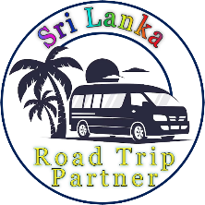

Sri Lanka Road Trip Partner

Explore Sri Lanka with us and create unforgettable memories.

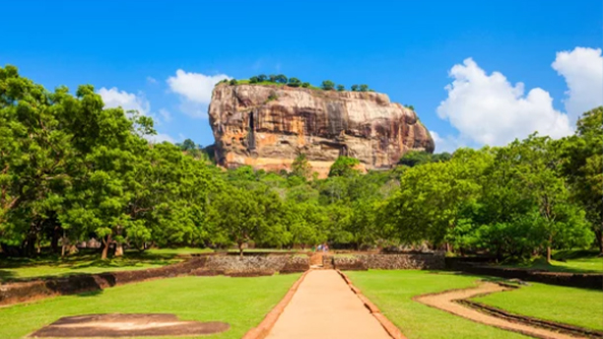
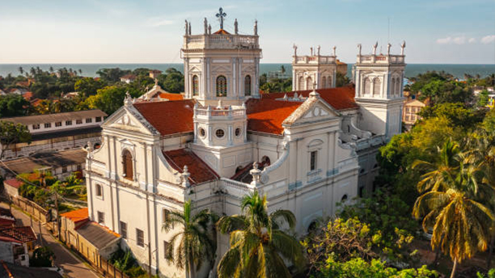

2 Day - Sigiriya
Sigiriya, also known as Lion Rock, is an ancient rock fortress and palace ruin, offering panoramic views and intricate frescoes.
Things to Do:
- Climb Sigiriya Rock Fortress
- Climb Pidurangala Rock
- Visit Dambulla Cave Temple
- Go on a Village Safari
- Go on a jeep Safari on Minneriya / Kaudulla National Park
- Ayurvedic massage treatments

1 Day - Negombo
Negombo is a vibrant coastal city known for its sandy beaches, bustling fish markets, and colonial architecture.
Things to Do:
- Visit Negombo Beach
- Dutch Canal Boat Ride
- Visit Negombo Fish Market (Lellama)
- Explore Negombo Night Market
- Visit St. Mary's Church
- Visit Angurukaramulla Temple

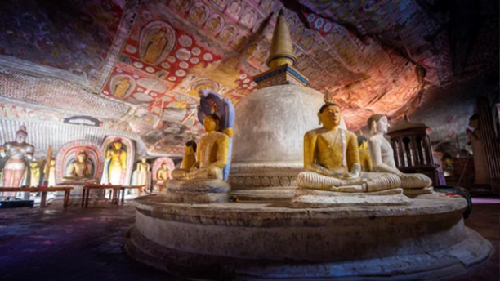
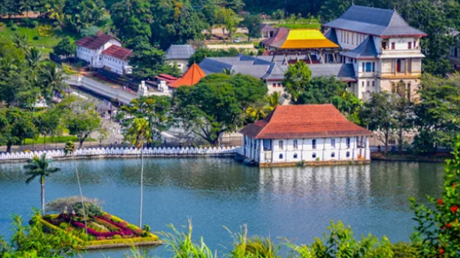

3 Day - Dambulla
Dambulla is renowned for its cave temple complex, the largest and best-preserved in Sri Lanka, adorned with Buddhist mural paintings and statues.
Things to Do:
- Visit Dambulla Cave Temple (Golden Temple)
- visit Golden Buddha Statue
- Go on a Village Safari
- Go on a jeep Safari on Minneriya / Kaudulla National Park
- Visit Local Marcket (Dambulla Economic Center)

4 Day - Kandy
Kandy is a cultural hub, home to the Temple of the Sacred Tooth Relic and the picturesque Kandy Lake.
Things to Do:
- Visit Temple of the Tooth Relic
- Visit Peradeniya Botanical Gardens
- Watch Kandyan Cultural Dance Show
- Visit Ambuluwawa Tower
- Visit Herbal Spice Gardens

5,6 Day - Ella
Ella is a small town surrounded by lush tea plantations, offering scenic views, hiking trails, and attractions like the Nine Arches Bridge.
Things to Do:
- Hike to Little Adam's Peak
- Visit Nine Arches Bridge
- Take the Train Ride
- Explore Ravana Falls
- Hike to Ella Rock
- Go Zip-lining at Flying Ravana
- Enjoy Night-lift in Ella

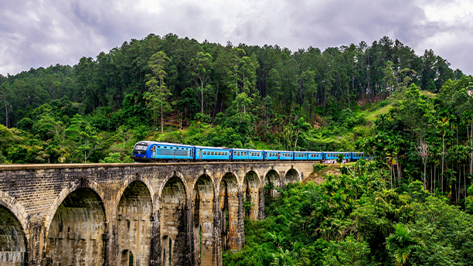

7 Day - Mirissa
Mirissa is famed for its stunning beaches and as a prime spot for whale watching.
Things to Do:
- Go Whale Watching
- Relax at Mirissa Beach
- Climb to Coconut Tree Hill
- Surfing at Weligama Beach
- Visit Secret Beach (Hidden Gem)
- Explore Parrot Rock
- Take a Catamaran Sailing Tour

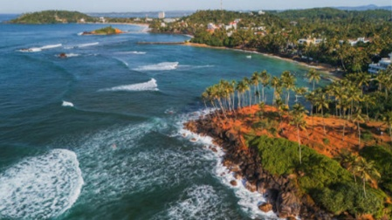

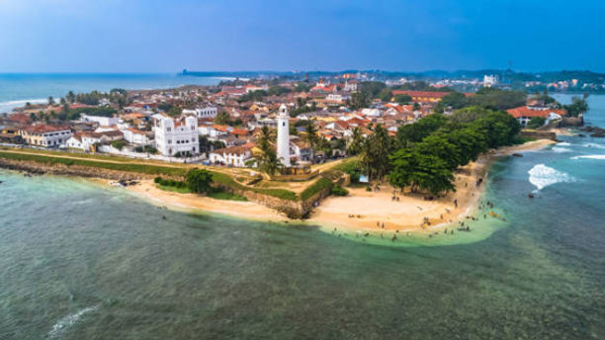

8 Day - Galle
Galle is a historic city featuring the UNESCO-listed Galle Fort, showcasing Dutch colonial architecture.
Things to Do:
- Explore Galle Fort
- Visit Galle Lighthouse
- Relax at Unawatuna Beach
- Explore Jungle Beach
- Visit Sea Turtle Hatchery
- Scuba Diving & Snorkeling

Sri Lanka Road Trip Partner

Package 1
(8 Days / 7 Nights )

We offer our own well-planned travel packages, and we welcome you to customize your own experience as well.

Have a Question?

Call Or WhatsApp :- + 94 77 19 53 880
Email :- malindutissera@gmail.com

Let's turn your travel dreams into reality one incredible adventure at a time!

